

Draw It or Lost It Web App

CS 230 Project Software Design Document
Version 3.0

Table of Contents

CS 230 Project Software Design Document 1
Table of Contents 2
Document Revision History 2
Executive Summary 3
Requirements 3
Design Constraints 3
System Architecture View 3
Domain Model 3
Evaluation 4
Recommendations 5

Document Revision History

Version | Date | Author | Comments
1.0 | 09/20/2026 | Matthew Saulenas | Initial draft
2.0 | 10/4/2026 | Matthew Saulenas | Project 2
3.0 | 10/23/2026 | Matthew Saulenas | Project 3

Executive Summary

The Gaming Room has launched their game, Draw It or Lose It, onto the Google Play Store. They wish to release a web-based version of the game. However, they lack the internal skills to achieve this and have engaged Creative Technology Solutions to consult, plan, and execute this project.

Requirements

- A game will have the ability to have one or more teams involved.
- Each team will have multiple players assigned to it.
- Game and team names must be unique to allow users to check whether a name is in use when choosing a team name.
- Only one instance of the game can exist in memory at any given time. This can be accomplished by creating unique identifiers for each instance of a game, team, or player.

Design Constraints

The game will be a client-server application where multiple clients will interact with the same server.
The client side/frontend of the application will act as the interface that the user interacts with and will not be responsible for any game logic.
Dynamic content in web-based applications must be programmed in JavaScript or TypeScript.
Vite is an excellent and light weight frontend build tool for building a single page web app to server as the front end.
Phaser 4 is a strong contender for the game engine as it is easy to embed into a single page react app.
The frontend application will need to be delivered to the client’s browser through a web server or a Platform-as-a-Service product, such as Azure Static Webapps.
The server side/backend API will be responsible for all game logic and act as the server in the client-server relationship.
The backend API will be written in Java with Spring Boot as the primary framework candidate.

System Architecture View

Please note: There is nothing required here for these projects, but this section serves as a reminder that describing the system and subsystem architecture present in the application, including physical components or tiers, may be required for other projects. A logical topology of the communication and storage aspects is also necessary to understand the overall architecture and should be provided.

Domain Model

The ProgramDriver class is the entry point of the application. The Game, Team, and Player objects inherit from the Entity object. There is a singleton class called GameService. It has 0 to many relationships with Game objects. A single instance of the Game object has 0 to many relationships with Team objects. A single instance of the Team object has 0 to many relationships with Player objects.



Evaluation

Development Requirements | Mac | Linux | Windows | Mobile Devices
Server Side | Not a feasible operating system for hosting.  Cons: MacOS server was discontinued in 2022. Unrealistic hardware costs and hosting expenses. | Preferred operating system.  Pros: Easy to secure, no licensing costs in most distributions, easy to scale, high performance, widely supported OS, broad container support  Cons: There are fewer skilled administrators in the work force; resulting in increased operating costs | Acceptable alternative operating system option.  Pros: Easy to secure, widely supported OS,  More skilled administrators in work force; reducing operational costs  Cons: Expensive licensing costs, poor container support | Mobile operating systems are not designed for server-side hosting. Hardware and maintainability costs make this option infeasible.
Client Side | Full WebGL support, limited WebGPU support in older supported versions of Safari but full support on Chrome. | Full WebGL support, limited WebGPU support in older supported versions of Firefox but full support on Chrome. | Full WebGL support, limited WebGPU support in older supported versions of Firefox but full support on Chrome. | Full WebGL support, limited WebGPU support in non-Chrome browsers.
Development Tools | JavaScript or TypeScript will be used to program the client-side application with static content and assets comprised of HTML5, CSS, png, svg, and/or webm files.  The server-side application will be programmed in Java.  Both applications can be built for Linux or Windows. A web server will deliver the client application to the user’s browser.  The two applications will be stored in a monorepo. A monorepo is preferred here since there are two separate but closely related applications. This will simplify Continuous Integration (CI) checks to trigger tests against both applications when a change is only made to a single application. However, managing two applications in a single project increases repo management. This can be mitigated by using TurboRepo as the build system and Mise as the tool and environment manager. TurboRepo will provide a single entry point for builds and CI tests. Mise will simplify and consistently replicate the developer experience across all developer workstations. This is important to streamline the onboarding of new developers to the team.  As this is a monorepo, VS Code is the preferred IDE. However, JSTORM for the JavaScript/TypeScript and IntelliJ or Eclipse are viable options as well.  CI/CD will be performed by Gitlab CI/CD. The client-side application testing will be performed with BrowserStack. This will prevent the need to test the application on every single platform and available hardware. Without this, the skills and hardware needed to perform full end-to-end testing may be financially infeasible give the projects budgetary constraints.  Application visibility should be considered from the start. This will allow for clear paths for developers to add logging, create alerts, and understand how the applications are behaving. OpenTelemetry is a common observability framework to allow your application to send its observability data to various backend systems. Grafana Labs provides many powerful opensource solutions for observability that works with OpenTelemetry. Grafana is a powerful metrics visualizer. Loki is a powerful log aggregation tool. Prometheus is one of the best time-series metrics and application monitoring tools available.

Recommendations

Analyze the characteristics of and techniques specific to various systems architectures and make a recommendation to The Gaming Room. Specifically, address the following:

- Operating Platform: Linux is the preferred operating platform. However, Windows is also a viable option.

- Operating Systems Architectures: Linux has significant industry support, it is easy to maintain, and it has reduced licensing costs. It also has native containerd support. This will allow The Gaming Room to create containers that conform to the Open Container Initiative (OCI) standards. This will allow The Game Room to use the container engine of their choice, assuming it is OCI compliant. This makes it an easy first option due to the reusability of the configuration and infrastructure for other projects while maintaining strong security stands and reduced costs.

- Storage Management: Storage management must be approached differently for the Server-side and Client-side.

  - Server-Side: On the server-side, the assets should be stored separately from the server application. This serves two major purposes; it reduces file duplication and container image size and allows the assets to be maintained separately from the server. This will allow the artists to upload the assets without having direct server access and it will simplify horizontal scaling strategies. A blob storage solution, such as an Azure Storage Account or AWS S3 bucket is a good option for this.
  - Client-Side: On the client-side, the focus should be on retrieving the assets just-in-time. This means that the players will only download the images that are needed for the scheduled rounds. They can be stored in the browser cache and loaded into memory when needed. This is important for mobile devices as they tend to have less storage capacity compared to other client devices. This will prevent the client-side application from consuming excessive storage space on the client device at the cost of increased bandwidth and server processing time.

- Memory Management: Memory management must also be approached differently for the Server-side and Client-side.
  - Server-Side: If the storage is offloaded to a blob storage solution, the server application can act as a security layer and reverse proxy to protect your proprietary image assets and stream the image files back to the client. If the image files are large, they can be streamed from the backend blob storage container. This will increase connection hold times but will reduce the consumed memory per image. This is because the images will not need to be fully loaded into memory.
  - Client-Side: Loading all possible images into memory at once will consume excessive memory. To mitigate this, the client-side application can load the images required for a single round into memory at once. This can be further optimized by only loading the current and next image into memory. Once the current image has been changed, the next image can begin to be loaded.
- Distributed Systems and Networks:
Due to the rest API and microservice architecture of the application, the client devices can communicate with the Game Server and UserServices with a predictable and widely supported interface. If the client devices support html5 or higher, JavaScript, OpenGL, http, and IP/TCP, the device should be able interact with the game. However, repeated regression testing is required to formally support specific devices as edge cases may exist. Should a client device disconnect from the Game Server, it should be able to reconnect with the session ID stored in an http cookie. The Game server has a hard dependency on the asset blob storage backend. The storage solution utilized should be highly available. This can be achieved by allowing for geo-redundancy if the storage solution supports it. Below is an example network diagram. The client device will download the client-side application from the DrawItOrLoseIt-Frontend server. The application will then run in the client device web browser or as a standalone progressive web app. This application will connect to the DrawItOrLoseIt Game Server to initialize or join an existing game. If the user is not authenticated, it will connect to the UserService over https to handle user authentication and process their user information.
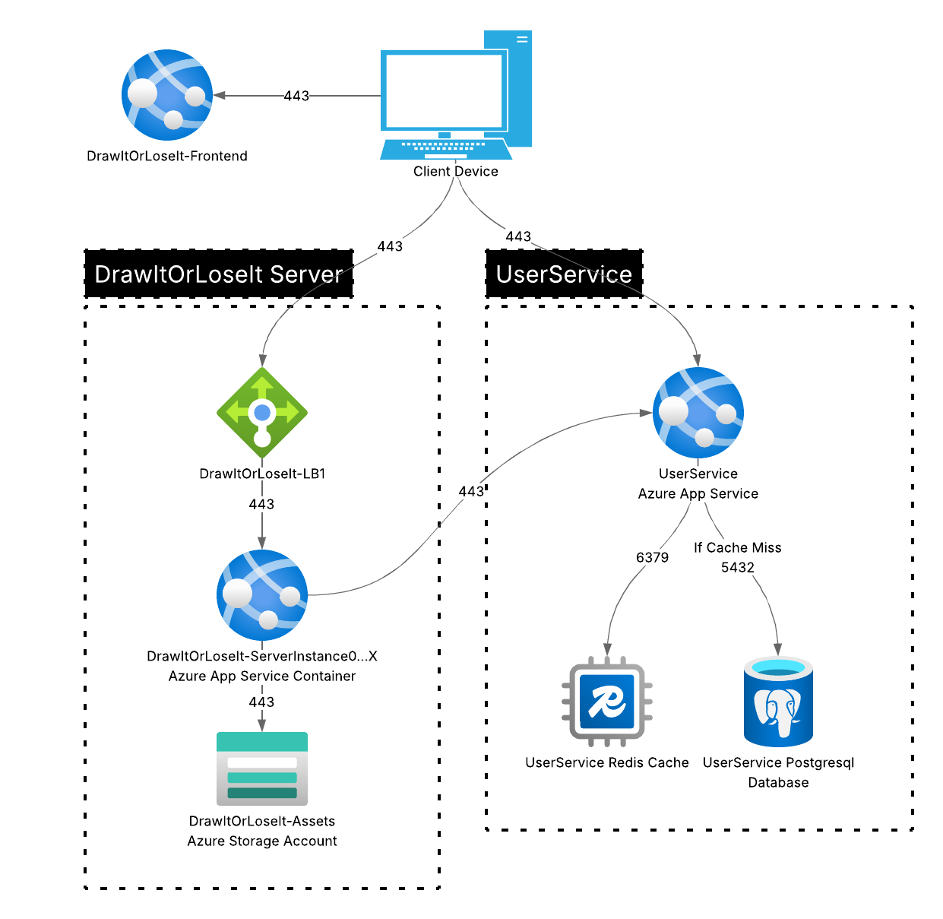
- Security: If the Game Server is also processing user account information, the application will be monolithic and will handle many concerns. This increases complexity in the application and prevents code re-use. To mitigate this, Creative Technology Solutions recommends implementing a UserService application. This allows for a separation of concerns between the game server component and the UserService component. The UserService can be reused by other games created by The Gaming Room. This positions The Gaming Room for continued growth. This allows The Gaming Room to limit the number of developers and administrators who have privileged access to the Personally Identifiable Information (PII) if the users. This would also limit the scope of access a threat actor has should a vulnerability exist in the DrawItOrLoseIt Server application, as the application would not have direct access to user data. The UserService would rely on a PostgreSQL Database for persistence with a Redis cache to reduce retrieval time of frequently accessed information. In addition, using a separate UserService allows user information access to be authorized centrally at the service.

References
contrainerd Project Team. (n.d.). Containerd – README. Containerd. Retrieved October 25, 2026, from https://containerd.io/docs/2.4/
Mozilla. (2025, March 14). Using HTTP cookies - HTTP | MDN. MDN Web Docs. https://developer.mozilla.org/en-US/docs/Web/HTTP/Guides/Cookies
Ostrowski, S. (2024, March 27). Containerd vs. docker | docker. Docker. https://www.docker.com/blog/containerd-vs-docker/
PostgreSQL. (2020, November 12). 1. What is PostgreSQL? PostgreSQL Documentation. https://www.postgresql.org/docs/current/intro-whatis.html
Redis. (2026, September 16). Redis cache-aside. Docs. https://redis.io/docs/latest/develop/use-cases/cache-aside/
seanmcc-msft. (2023, June 27). Understanding block blobs, append blobs, and page blobs - azure storage. MicrosoftLearn. https://learn.microsoft.com/en-us/rest/api/storageservices/understanding-block-blobs--append-blobs--and-page-blobs

